Sum-Meet
Data Design Document

Submitted to:

Asst. Prof. Ma. Rowena C. Solamo
Faculty Member
Department of Computer Science
College of Engineering
University of the Philippines, Diliman

Submitted by:
Batula, Bryce Spencer
Bayuga, Michael John
Yap, John Theodore

In partial fulfillment of Academic Requirements
for the course
CS 191 Software Engineering I
of the
1st Semester, AY 2014-2015
Revision Control

History Revision:
Revision Date | Person Responsible | Version  Number | Modification
10/29/15 | Michael John Bayuga | 1.0 | Initial Document; Version number should match the one found in the footer.

Data Design:

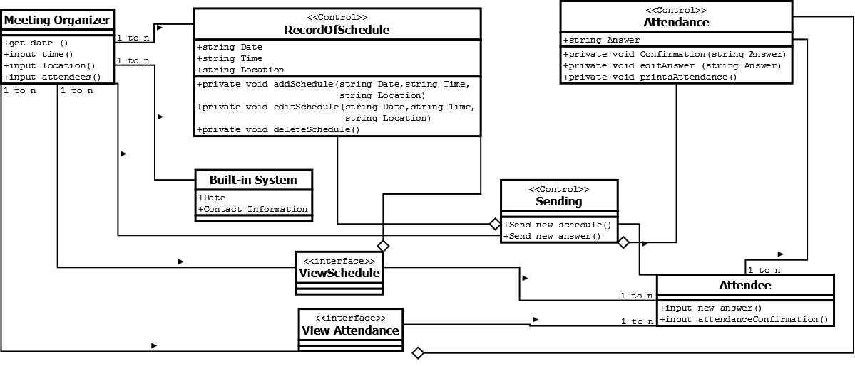

Data Access Object (DAO) Classes:
Class Name | Description

Transfer Object Classes:
Class Name | Description

List of Data Source:

File Name: [Filename of Data Source]
Description: [Description of the contents of the file.]

Sample Source File:
root:!:0:0::/:/usr/bin/ksh
daemon:!:1:1::/etc:
bin:!:2:2::/bin:
sys:!:3:3::/usr/sys:
adm:!:4:4::/var/adm:
uucp:!:5:5::/usr/lib/uucp:
guest:!:100:100::/home/guest:
nobody:!:4294967294:4294967294::/:

